**RENTED VEHICLE MANAGEMENT SYSTEM**

**Vehicles with SUV and Sedan Vehicle type only**

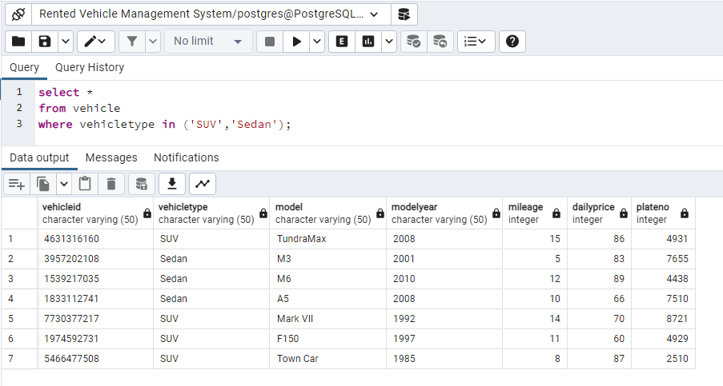

**Employee’s not in Sales Department**

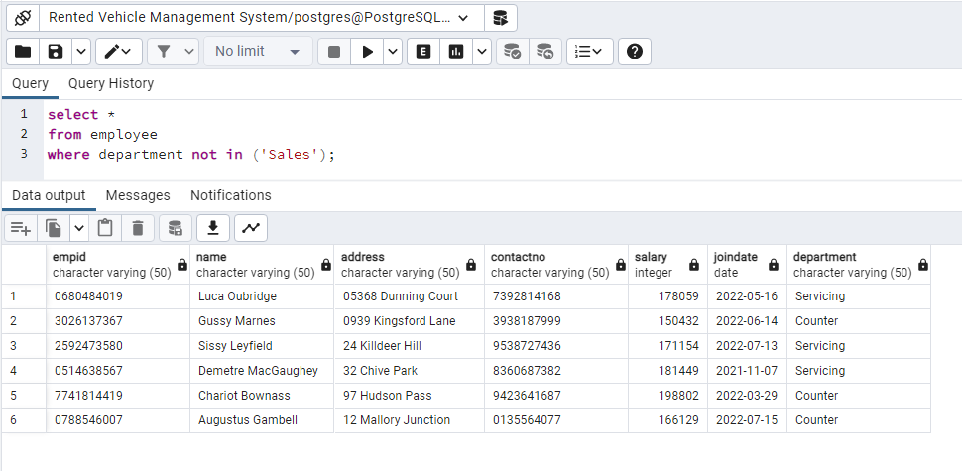

**List of Reservations where the return date is in between the 2 dates**

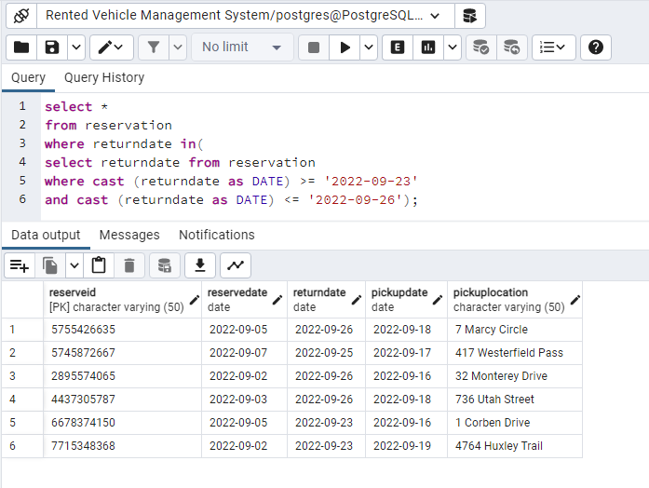

**List of Reservations where the return date is not in between the 2 dates**

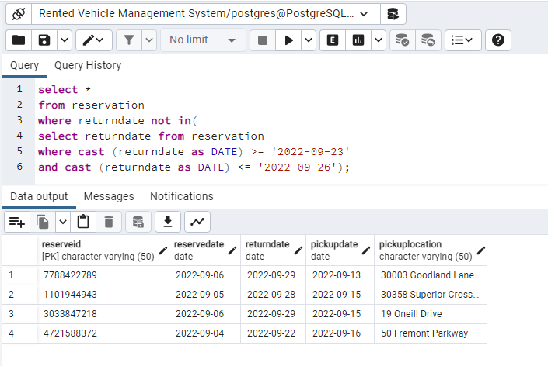

**Customers with Total Rent Pay less than $200**

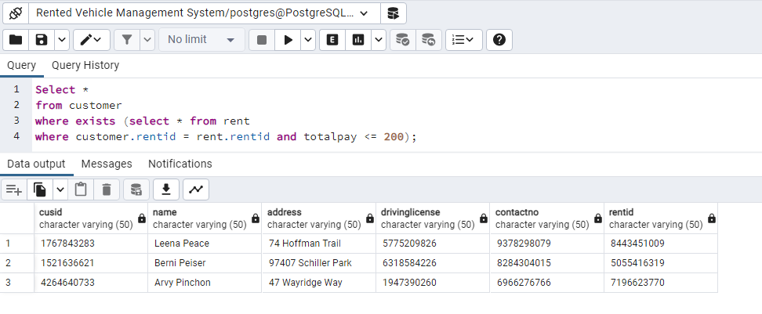

**Customers with Total Rent Pay greater than $200**

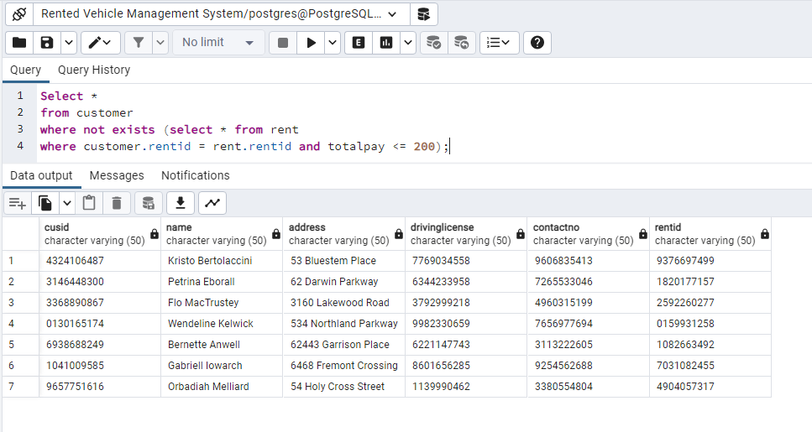

**Customers with Pay Date before 19-02-2022**

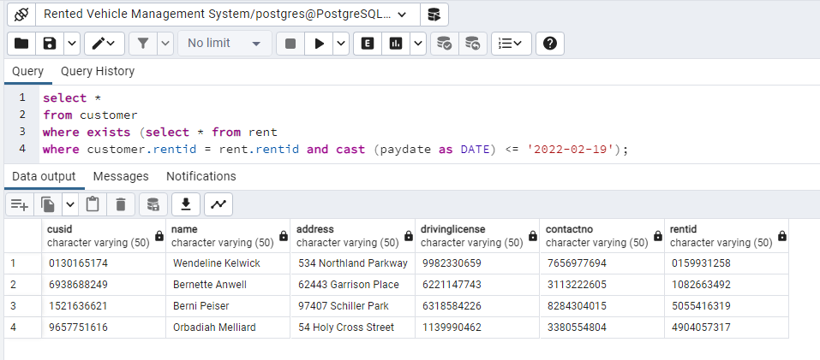

**Customers with Pay Date after 19-02-2022**

